|  |  |
| --- | --- |
| **Model** | GM |
| **Dependent Variable** | i_gm |
| **Label** | I |

| **Analysis of Variance** | | | | | |
| --- | --- | --- | --- | --- | --- |
| **Source** | **DF** | **Sum of Squares** | **Mean Square** | **F Value** | **Pr > F** |
| **Model** | 2 | 1677687 | 838843.3 | 99.58 | <.0001 |
| **Error** | 17 | 143205.9 | 8423.875 |  |  |
| **Corrected Total** | 19 | 1820893 |  |  |  |

|  |  |  |  |
| --- | --- | --- | --- |
| **Root MSE** | 91.78167 | **R-Square** | 0.92135 |
| **Dependent Mean** | 608.02000 | **Adj R-Sq** | 0.91210 |
| **Coeff Var** | 15.09517 |  |  |

| **Parameter Estimates** | | | | | | |
| --- | --- | --- | --- | --- | --- | --- |
| **Variable** | **DF** | **Parameter Estimate** | **Standard Error** | **t Value** | **Pr > |t|** | **Variable Label** |
| **Intercept** | 1 | -149.782 | 105.8421 | -1.42 | 0.1751 | Intercept |
| **f_gm** | 1 | 0.119281 | 0.025834 | 4.62 | 0.0002 | F |
| **c_gm** | 1 | 0.371445 | 0.037073 | 10.02 | <.0001 | C |

|  |  |
| --- | --- |
| **Model** | CH |
| **Dependent Variable** | i_ch |
| **Label** | I |

| **Analysis of Variance** | | | | | |
| --- | --- | --- | --- | --- | --- |
| **Source** | **DF** | **Sum of Squares** | **Mean Square** | **F Value** | **Pr > F** |
| **Model** | 2 | 31686.54 | 15843.27 | 89.86 | <.0001 |
| **Error** | 17 | 2997.444 | 176.3203 |  |  |
| **Corrected Total** | 19 | 34683.99 |  |  |  |

|  |  |  |  |
| --- | --- | --- | --- |
| **Root MSE** | 13.27856 | **R-Square** | 0.91358 |
| **Dependent Mean** | 86.12350 | **Adj R-Sq** | 0.90341 |
| **Coeff Var** | 15.41805 |  |  |

| **Parameter Estimates** | | | | | | |
| --- | --- | --- | --- | --- | --- | --- |
| **Variable** | **DF** | **Parameter Estimate** | **Standard Error** | **t Value** | **Pr > |t|** | **Variable Label** |
| **Intercept** | 1 | -6.18996 | 13.50648 | -0.46 | 0.6525 | Intercept |
| **f_ch** | 1 | 0.077948 | 0.019973 | 3.90 | 0.0011 | F |
| **c_ch** | 1 | 0.315718 | 0.028813 | 10.96 | <.0001 | C |

|  |  |
| --- | --- |
| **Model** | GE |
| **Dependent Variable** | i_ge |
| **Label** | I |

| **Analysis of Variance** | | | | | |
| --- | --- | --- | --- | --- | --- |
| **Source** | **DF** | **Sum of Squares** | **Mean Square** | **F Value** | **Pr > F** |
| **Model** | 2 | 31632.03 | 15816.02 | 20.34 | <.0001 |
| **Error** | 17 | 13216.59 | 777.4463 |  |  |
| **Corrected Total** | 19 | 44848.62 |  |  |  |

|  |  |  |  |
| --- | --- | --- | --- |
| **Root MSE** | 27.88272 | **R-Square** | 0.70531 |
| **Dependent Mean** | 102.29000 | **Adj R-Sq** | 0.67064 |
| **Coeff Var** | 27.25850 |  |  |

| **Parameter Estimates** | | | | | | |
| --- | --- | --- | --- | --- | --- | --- |
| **Variable** | **DF** | **Parameter Estimate** | **Standard Error** | **t Value** | **Pr > |t|** | **Variable Label** |
| **Intercept** | 1 | -9.95631 | 31.37425 | -0.32 | 0.7548 | Intercept |
| **f_ge** | 1 | 0.026551 | 0.015566 | 1.71 | 0.1063 | F |
| **c_ge** | 1 | 0.151694 | 0.025704 | 5.90 | <.0001 | C |

|  |  |
| --- | --- |
| **Model** | WE |
| **Dependent Variable** | i_we |
| **Label** | I |

| **Analysis of Variance** | | | | | |
| --- | --- | --- | --- | --- | --- |
| **Source** | **DF** | **Sum of Squares** | **Mean Square** | **F Value** | **Pr > F** |
| **Model** | 2 | 5165.553 | 2582.776 | 24.76 | <.0001 |
| **Error** | 17 | 1773.234 | 104.3079 |  |  |
| **Corrected Total** | 19 | 6938.787 |  |  |  |

|  |  |  |  |
| --- | --- | --- | --- |
| **Root MSE** | 10.21312 | **R-Square** | 0.74445 |
| **Dependent Mean** | 42.89150 | **Adj R-Sq** | 0.71438 |
| **Coeff Var** | 23.81153 |  |  |

| **Parameter Estimates** | | | | | | |
| --- | --- | --- | --- | --- | --- | --- |
| **Variable** | **DF** | **Parameter Estimate** | **Standard Error** | **t Value** | **Pr > |t|** | **Variable Label** |
| **Intercept** | 1 | -0.50939 | 8.015289 | -0.06 | 0.9501 | Intercept |
| **f_we** | 1 | 0.052894 | 0.015707 | 3.37 | 0.0037 | F |
| **c_we** | 1 | 0.092406 | 0.056099 | 1.65 | 0.1179 | C |

|  |  |
| --- | --- |
| **Model** | US |
| **Dependent Variable** | i_us |
| **Label** | I |

| **Analysis of Variance** | | | | | |
| --- | --- | --- | --- | --- | --- |
| **Source** | **DF** | **Sum of Squares** | **Mean Square** | **F Value** | **Pr > F** |
| **Model** | 2 | 139978.1 | 69989.04 | 6.69 | 0.0072 |
| **Error** | 17 | 177928.3 | 10466.37 |  |  |
| **Corrected Total** | 19 | 317906.4 |  |  |  |

|  |  |  |  |
| --- | --- | --- | --- |
| **Root MSE** | 102.30529 | **R-Square** | 0.44031 |
| **Dependent Mean** | 405.46000 | **Adj R-Sq** | 0.37447 |
| **Coeff Var** | 25.23191 |  |  |

| **Parameter Estimates** | | | | | | |
| --- | --- | --- | --- | --- | --- | --- |
| **Variable** | **DF** | **Parameter Estimate** | **Standard Error** | **t Value** | **Pr > |t|** | **Variable Label** |
| **Intercept** | 1 | -30.3685 | 157.0477 | -0.19 | 0.8490 | Intercept |
| **f_us** | 1 | 0.156571 | 0.078886 | 1.98 | 0.0635 | F |
| **c_us** | 1 | 0.423866 | 0.155216 | 2.73 | 0.0142 | C |

| **Cross Model Covariance** | | | | | |
| --- | --- | --- | --- | --- | --- |
|  | **GM** | **CH** | **GE** | **WE** | **US** |
| **GM** | 8423.88 | -332.655 | 714.74 | 148.443 | -2614.2 |
| **CH** | -332.65 | 176.320 | -25.15 | 15.655 | 491.9 |
| **GE** | 714.74 | -25.148 | 777.45 | 207.587 | 1064.6 |
| **WE** | 148.44 | 15.655 | 207.59 | 104.308 | 642.6 |
| **US** | -2614.19 | 491.857 | 1064.65 | 642.571 | 10466.4 |

| **Cross Model Correlation** | | | | | |
| --- | --- | --- | --- | --- | --- |
|  | **GM** | **CH** | **GE** | **WE** | **US** |
| **GM** | 1.00000 | -0.27295 | 0.27929 | 0.15836 | -0.27841 |
| **CH** | -0.27295 | 1.00000 | -0.06792 | 0.11544 | 0.36207 |
| **GE** | 0.27929 | -0.06792 | 1.00000 | 0.72896 | 0.37323 |
| **WE** | 0.15836 | 0.11544 | 0.72896 | 1.00000 | 0.61499 |
| **US** | -0.27841 | 0.36207 | 0.37323 | 0.61499 | 1.00000 |

| **Cross Model Inverse Correlation** | | | | | |
| --- | --- | --- | --- | --- | --- |
|  | **GM** | **CH** | **GE** | **WE** | **US** |
| **GM** | 1.41160 | 0.14649 | -0.32667 | -0.46056 | 0.74512 |
| **CH** | 0.14649 | 1.23373 | 0.27615 | -0.08670 | -0.45566 |
| **GE** | -0.32667 | 0.27615 | 2.33055 | -1.65117 | -0.04531 |
| **WE** | -0.46056 | -0.08670 | -1.65117 | 3.16367 | -1.42618 |
| **US** | 0.74512 | -0.45566 | -0.04531 | -1.42618 | 2.26642 |

| **Cross Model Inverse Covariance** | | | | | |
| --- | --- | --- | --- | --- | --- |
|  | **GM** | **CH** | **GE** | **WE** | **US** |
| **GM** | 0.000168 | 0.000120 | -.000128 | -.000491 | 0.000079 |
| **CH** | 0.000120 | 0.006997 | 0.000746 | -.000639 | -.000335 |
| **GE** | -.000128 | 0.000746 | 0.002998 | -.005798 | -.000016 |
| **WE** | -.000491 | -.000639 | -.005798 | 0.030330 | -.001365 |
| **US** | 0.000079 | -.000335 | -.000016 | -.001365 | 0.000217 |

|  |  |
| --- | --- |
| **System Weighted MSE** | 0.9401 |
| **Degrees of freedom** | 85 |
| **System Weighted R-Square** | 0.8707 |

|  |  |
| --- | --- |
| **Model** | GM |
| **Dependent Variable** | i_gm |
| **Label** | I |

| **Parameter Estimates** | | | | | | |
| --- | --- | --- | --- | --- | --- | --- |
| **Variable** | **DF** | **Parameter Estimate** | **Standard Error** | **t Value** | **Pr > |t|** | **Variable Label** |
| **Intercept** | 1 | -162.364 | 97.03216 | -1.67 | 0.1126 | Intercept |
| **f_gm** | 1 | 0.120493 | 0.023460 | 5.14 | <.0001 | F |
| **c_gm** | 1 | 0.382746 | 0.035542 | 10.77 | <.0001 | C |

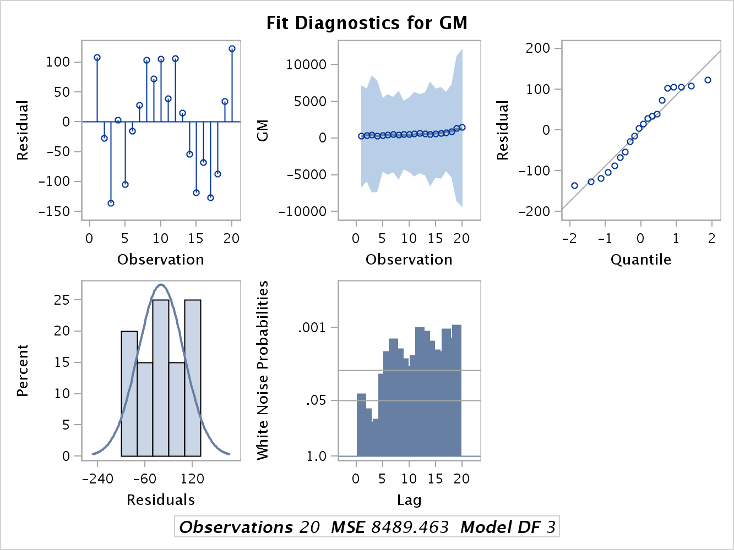

|  |  |
| --- | --- |
| **Model** | CH |
| **Dependent Variable** | i_ch |
| **Label** | I |

| **Parameter Estimates** | | | | | | |
| --- | --- | --- | --- | --- | --- | --- |
| **Variable** | **DF** | **Parameter Estimate** | **Standard Error** | **t Value** | **Pr > |t|** | **Variable Label** |
| **Intercept** | 1 | 0.504304 | 12.48742 | 0.04 | 0.9683 | Intercept |
| **f_ch** | 1 | 0.069546 | 0.018328 | 3.79 | 0.0014 | F |
| **c_ch** | 1 | 0.308545 | 0.028053 | 11.00 | <.0001 | C |

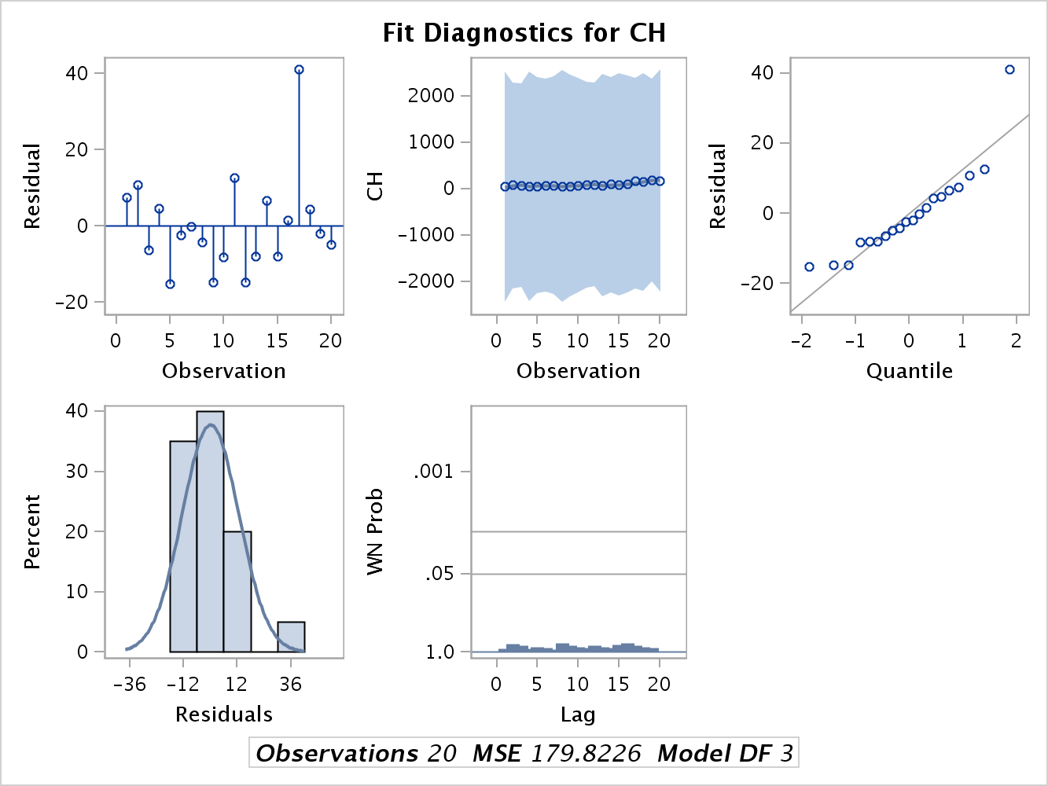

|  |  |
| --- | --- |
| **Model** | GE |
| **Dependent Variable** | i_ge |
| **Label** | I |

| **Parameter Estimates** | | | | | | |
| --- | --- | --- | --- | --- | --- | --- |
| **Variable** | **DF** | **Parameter Estimate** | **Standard Error** | **t Value** | **Pr > |t|** | **Variable Label** |
| **Intercept** | 1 | -22.4389 | 27.67879 | -0.81 | 0.4287 | Intercept |
| **f_ge** | 1 | 0.037291 | 0.013301 | 2.80 | 0.0122 | F |
| **c_ge** | 1 | 0.130783 | 0.023916 | 5.47 | <.0001 | C |

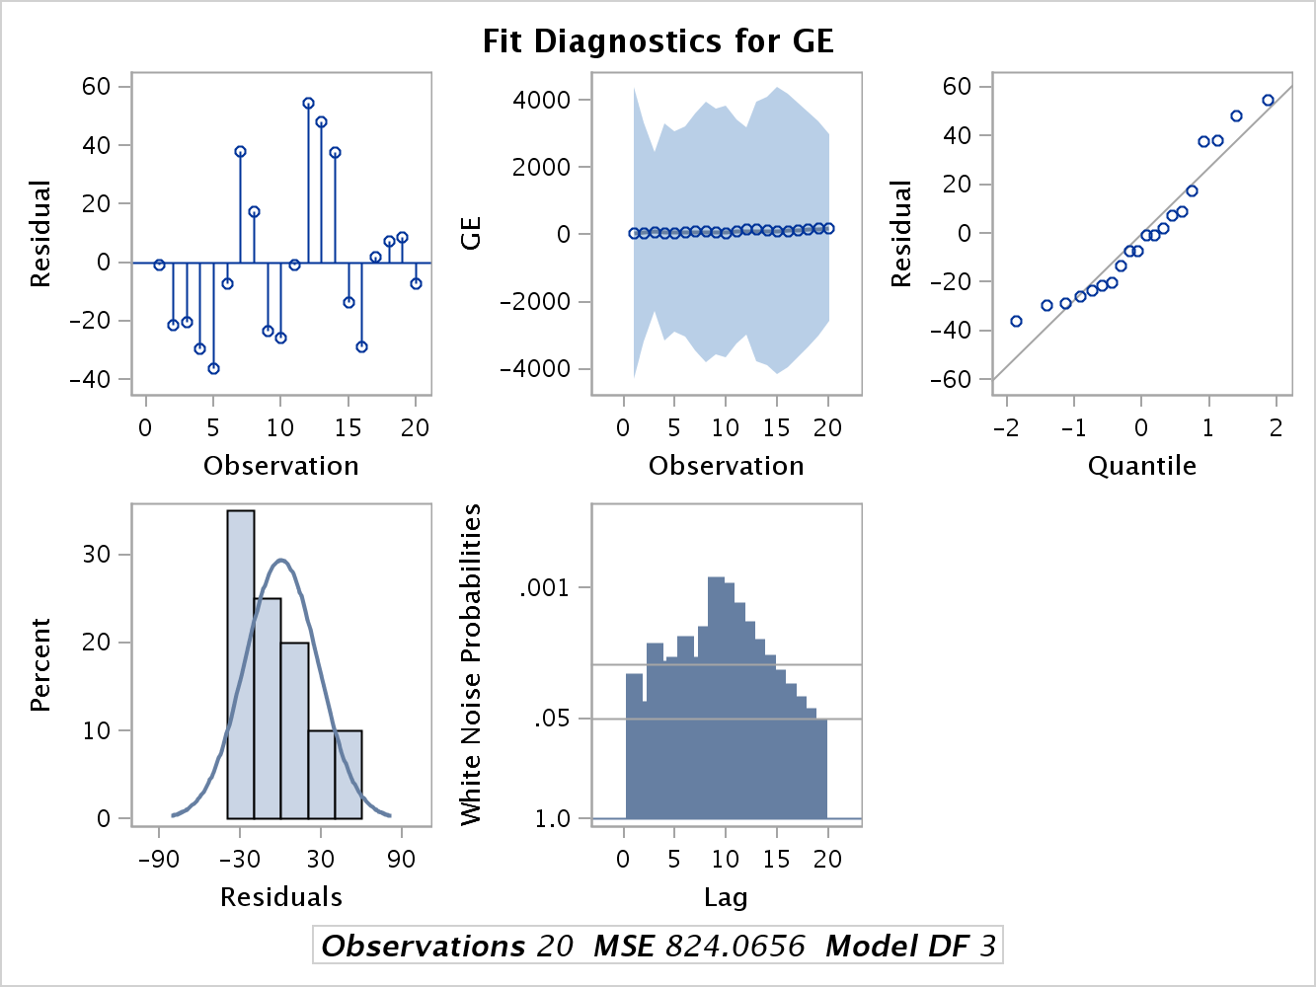

|  |  |
| --- | --- |
| **Model** | WE |
| **Dependent Variable** | i_we |
| **Label** | I |

| **Parameter Estimates** | | | | | | |
| --- | --- | --- | --- | --- | --- | --- |
| **Variable** | **DF** | **Parameter Estimate** | **Standard Error** | **t Value** | **Pr > |t|** | **Variable Label** |
| **Intercept** | 1 | 1.088877 | 6.788627 | 0.16 | 0.8745 | Intercept |
| **f_we** | 1 | 0.057009 | 0.012324 | 4.63 | 0.0002 | F |
| **c_we** | 1 | 0.041506 | 0.044689 | 0.93 | 0.3660 | C |

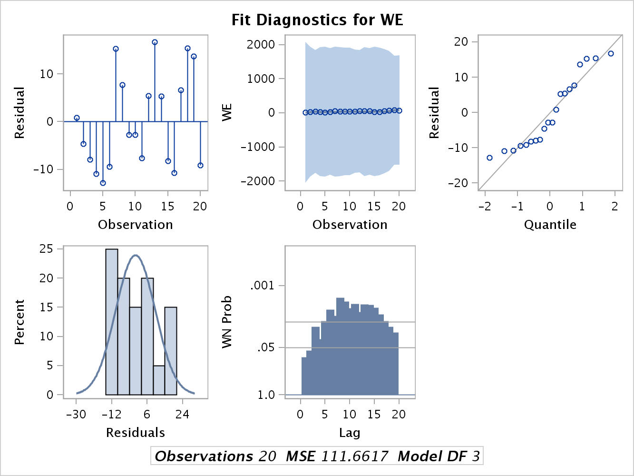

|  |  |
| --- | --- |
| **Model** | US |
| **Dependent Variable** | i_us |
| **Label** | I |

| **Parameter Estimates** | | | | | | |
| --- | --- | --- | --- | --- | --- | --- |
| **Variable** | **DF** | **Parameter Estimate** | **Standard Error** | **t Value** | **Pr > |t|** | **Variable Label** |
| **Intercept** | 1 | 85.42325 | 121.3481 | 0.70 | 0.4910 | Intercept |
| **f_us** | 1 | 0.101478 | 0.059421 | 1.71 | 0.1059 | F |
| **c_us** | 1 | 0.399991 | 0.138613 | 2.89 | 0.0103 | C |

